**Numerical Propagation of Schrodinger's Equation**

( <http://www.physics.purdue.edu/~robichf/qmmovies/theory.htm> )

数值求解含时薛定谔方程的方法(1)

Introduction to Quantum Mechanics(2)

The definition of Fourier transformation and inverse Fourier transformation,





Normalized Gaussian wavefunction



for which





Normalized Gaussian broadening function



for which



At *t* = 0,



Define



Insert the Fourier transformation of Eq. into ,



The wavefunction at time *t* can be written as



Define



























Then Eq. becomes



Define





And















Define



















Then

















### Boltzmann







or







### Fermi













### Bose



















where







When



Boltzmann









Fermi











So



and



Bose









So



and















when 





















when 



















when 





























2004, Using preconditioned adaptive step size Runge-Kutta methods for solving the time-dependent Schrödinger equation(3)

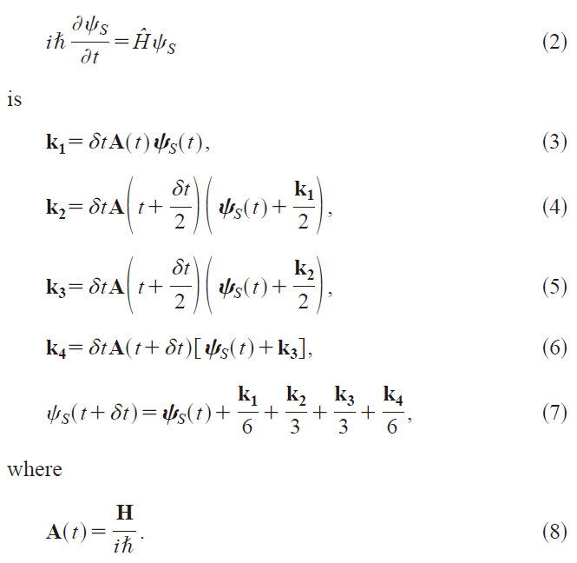





















where *s* ≪1.



























































Set 



Here we do not know , , ……, , set ,















































































Define





































Define





Insert and into





















































































































**References:**

(1) 徐天宇, 何峰: 数值求解含时薛定谔方程的方法.

(2) DJ Griffiths: Introduction to Quantum Mechanics, Benjamin Cummings, 2004.

(3) JC Tremblay, T Carrington: Using preconditioned adaptive step size Runge-Kutta methods for solving the time-dependent Schrödinger equation. J. Chem. Phys. 121 (2004) 11535-41.

**校对报告**

当前使用的样式是 [Chemical Physics Letters]

当前文档包含的题录共3条

有0条题录存在必填字段内容缺失的问题

所有题录的数据正常